**Your Name: Purnabhishek Sriapathi**

**Grading Policy: In order to get credit for each screenshot,** you **MUST** have the repository named as ***BAN540_YourLastName*** with**LoanDefault_Dataset_YourLastName** and**ProblemSolving_KNN_YourLastName** in it. The repository and data files **MUST** be clearly shown in your screenshot as my examples below. If not, you will get ZERO for that particular screenshot which doesn’t show them clearly.

**Screenshot #1 (6 points)**

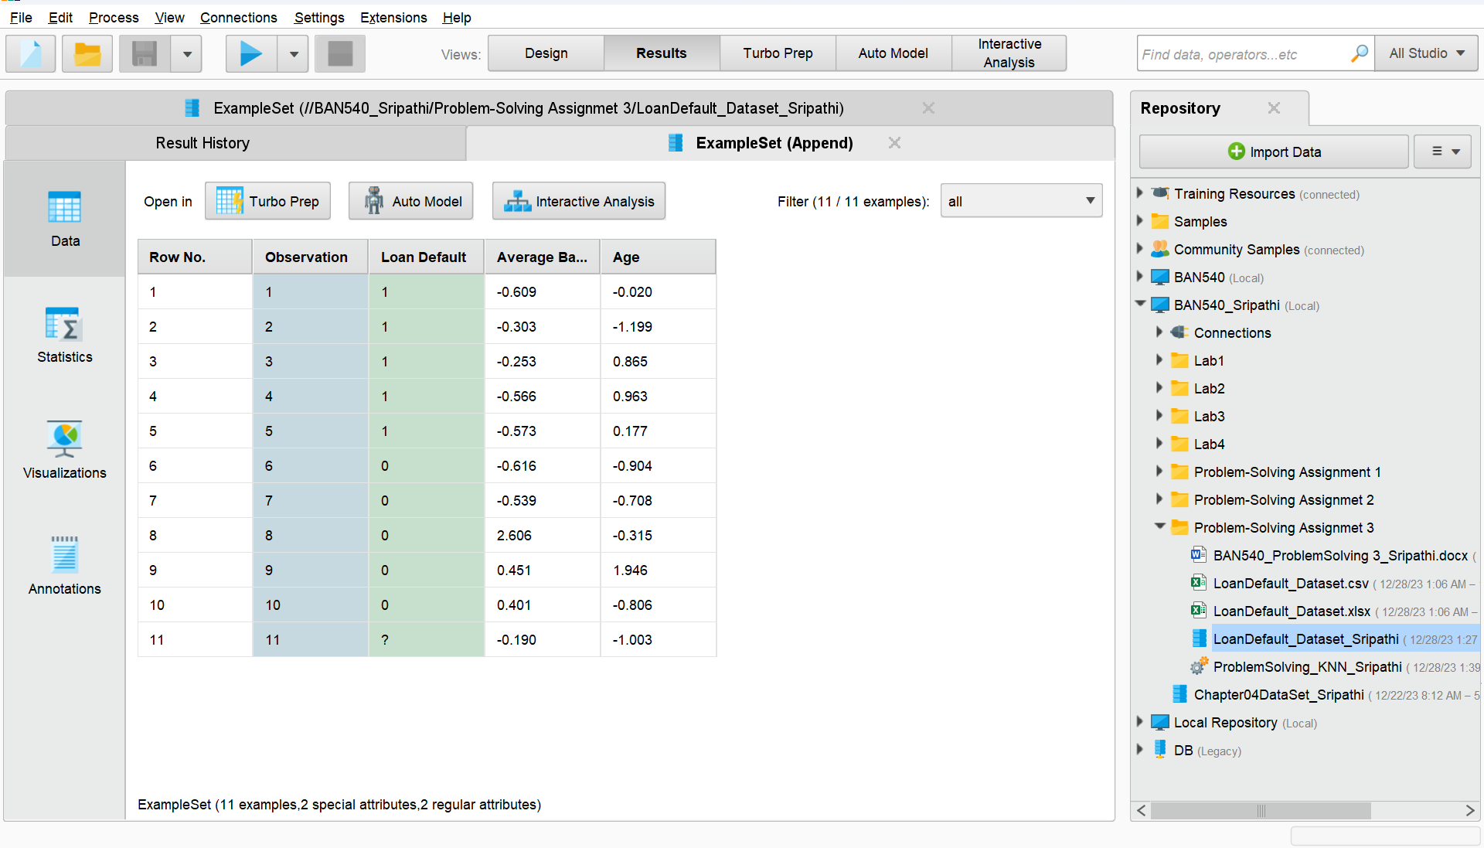

**Screenshot #2 (6 points)**

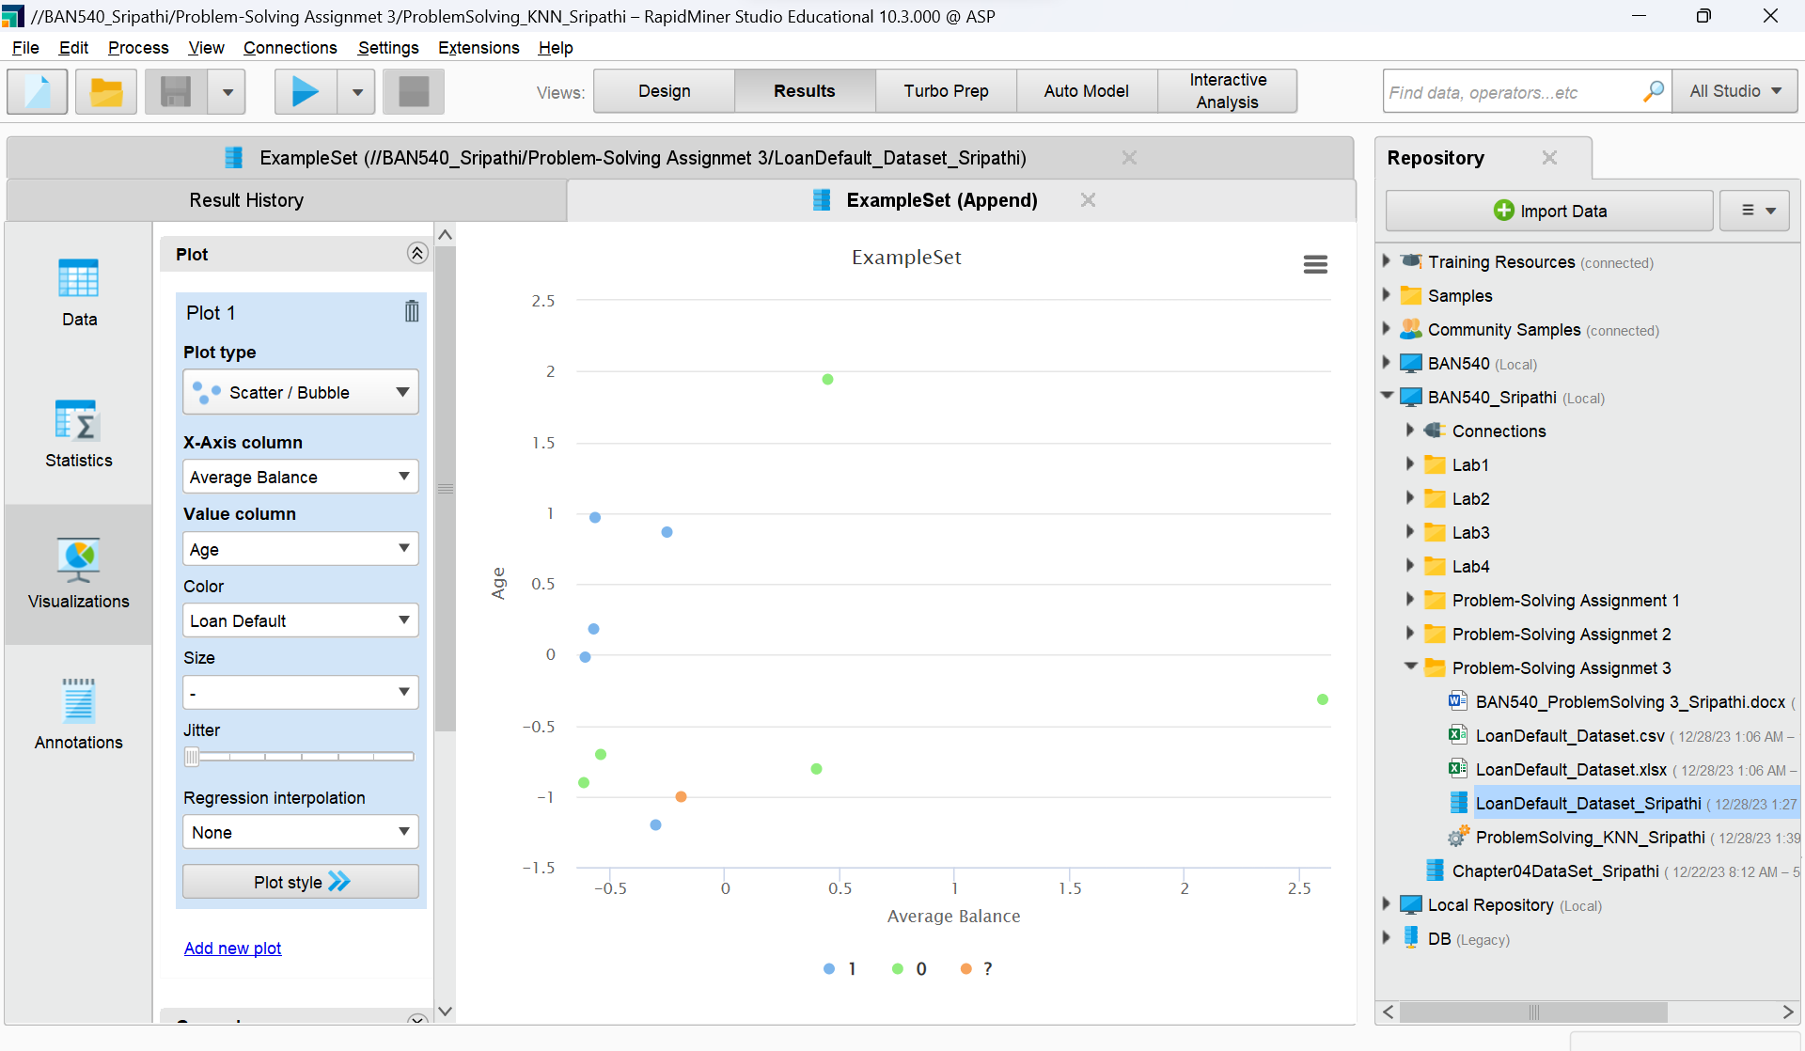

**Screenshot #3 (6 points)**

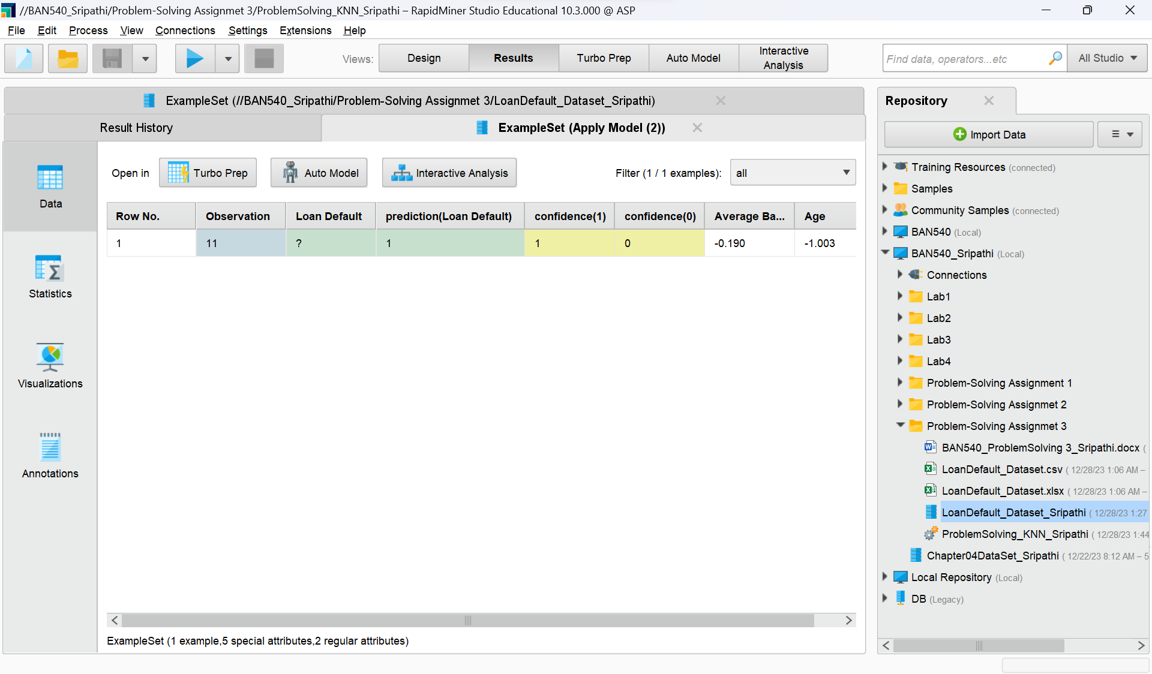

**Screenshot #4 (6 points)**

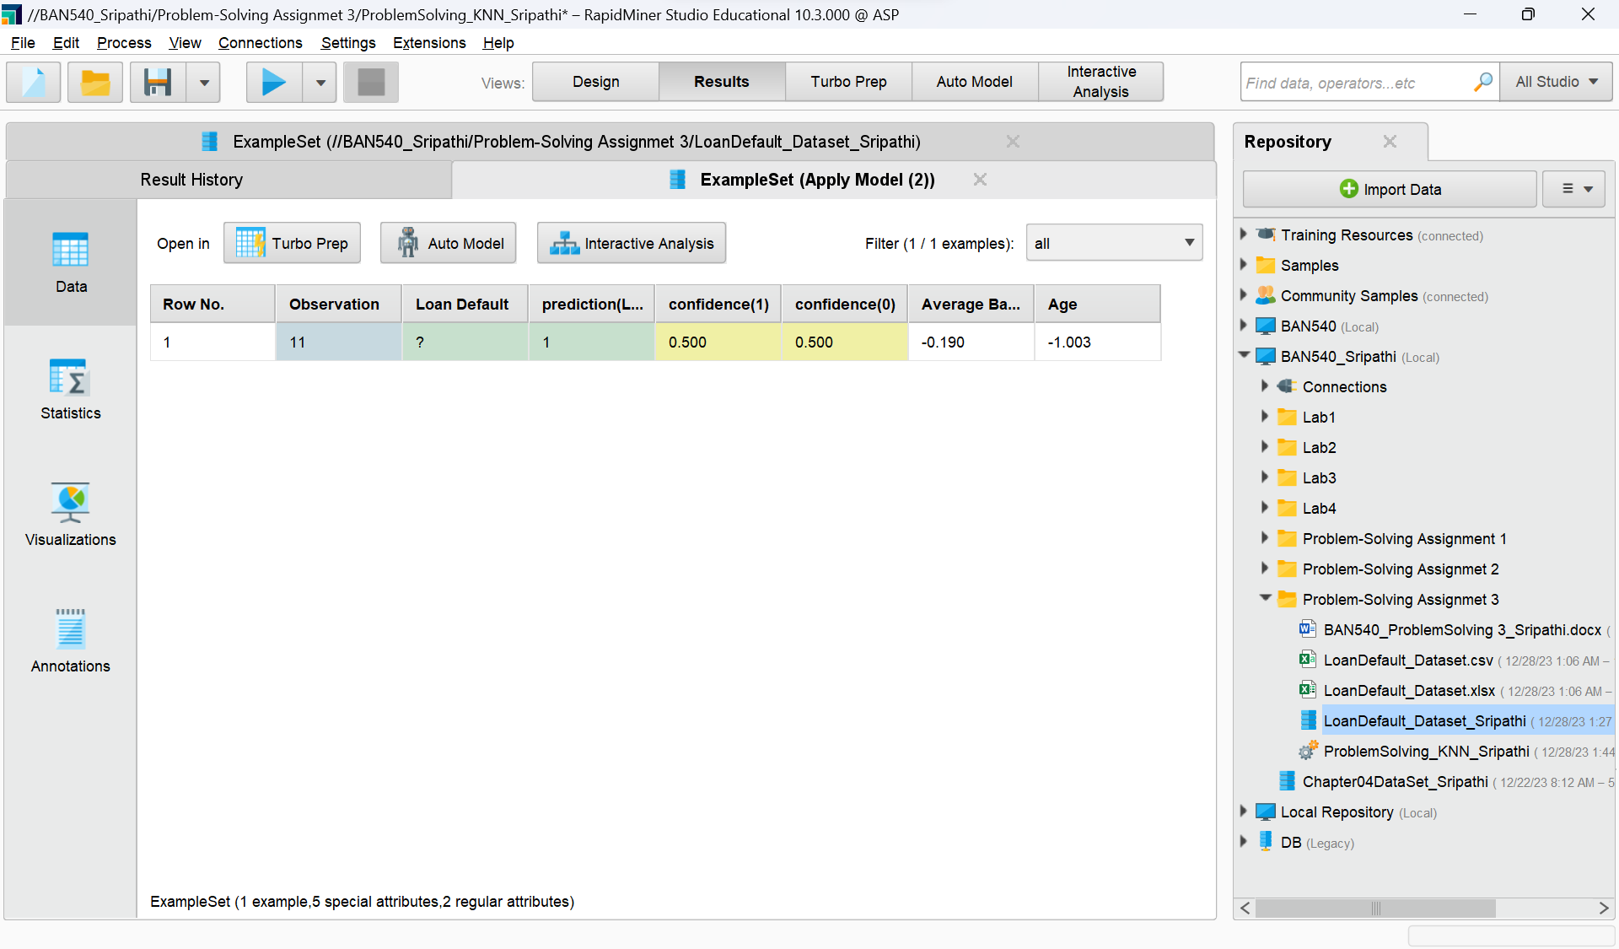

**Screenshot #5 (5 points)**

**Screenshot #6 (5 points)**

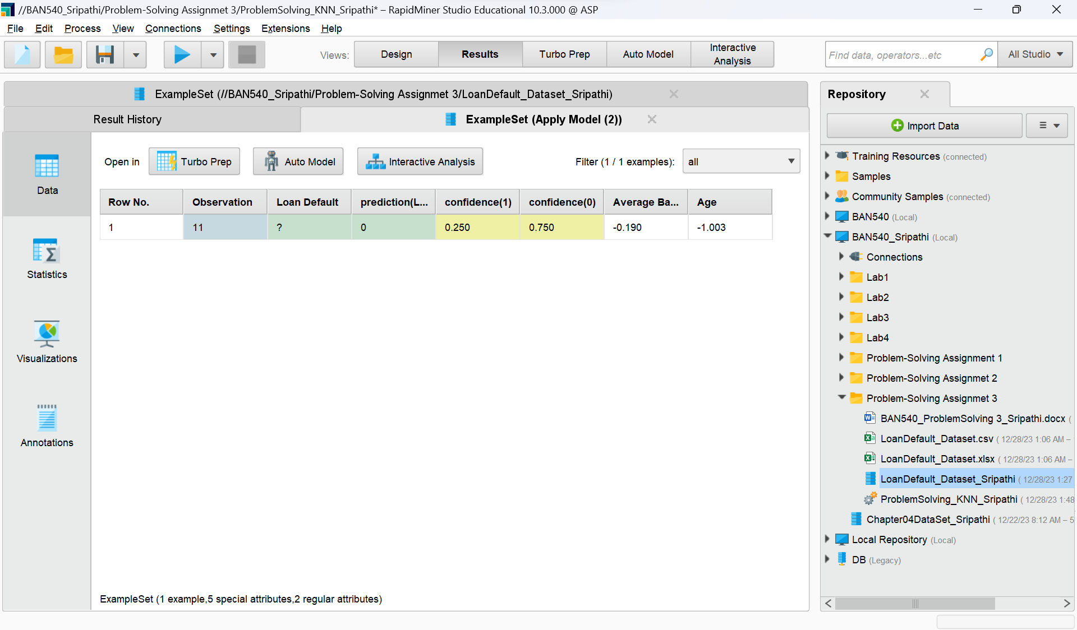

**Please continue to run your k-NN model in RapidMiner using k=7, 8, 9 and 10 respectively, and complete the following table by replacing all the (?)s with your answers (16 points).**

|  |  |  |  |  |  |
| --- | --- | --- | --- | --- | --- |
| **k** | **confidence(1)**  **(% of Class 1 Neighbors)** | **Number of blue dots** | **confidence(0)**  **(% of Class 0 Neighbors)** | **Number of green dots** | **Prediction(Loan Default)** |
| 1 | 1 | 1 | 0 | 0 | 1 |
| 2 | 0.5 | 1 | 0.5 | 1 | 1 |
| 3 | 0.333 | 1 | 0.667 | 2 | 0 |
| 4 | 0.25 | 1 | 0.75 | 3 | 0 |
| 5 | 0.4 | 2 | 0.6 | 3 | 0 |
| 6 | 0.5 | 3 | 0.5 | 3 | 1 |
| 7 | **0.571** | **4** | **0.429** | **3** | 1 |
| 8 | **0.625** | **5** | **0.375** | **3** | 1 |
| 9 | **0.556** | **5** | **0.444** | **4** | 1 |
| 10 | **0.500** | **5** | **0.500** | **5** | 1 |